**PB Offer Adjustment Recommendations for Suggested Offers v1.r3**

**By William Miller, 7/26/19**

During the first month of testing suggested offers v1.r3, it has become apparent that the suggested offers for PBs have far exceeded chain average. As of 7/23/19, suggested offers for PBs averaged $0.56 per PB, whereas the chain average offer per PB was $0.34.

In order to make a recommendation as to potential adjustments to suggested offers for PBs, I performed the following analysis.

First, I examined the frequency with which PBs sell at particular values of “Days Scanned to Shelf w/ Trash Penalty”.

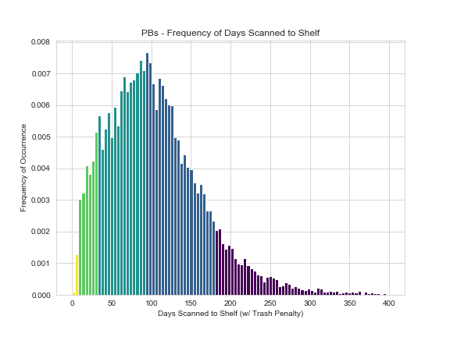

From the above it can be determine that most merchandise sells at a little under 100 days scanned to the shelf after penalty. Most PBs sell after 90 days. This indicates that it is likely that merchandise in the dark green and dark blue areas of the chart that primarily determine the average suggested offer for PBs.

Next I examined the frequency with which suggested offer amounts have occurred.

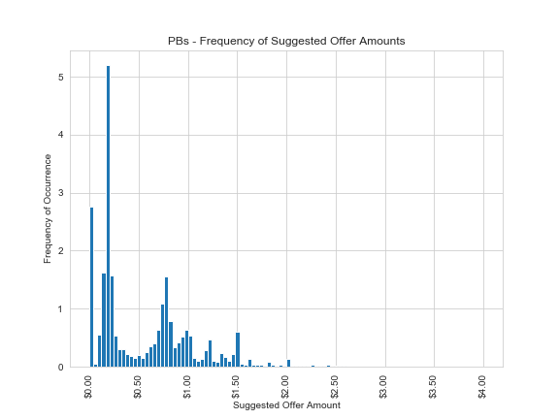

Looking at the frequency of PB suggested offer distribution, it is clear that PB suggested offers tend to fall into one of three primary offer groups: those for which we offer $0.00, those for which we offer around $0.25, and those for which we offer around $0.75. This likely corresponds with buy grades E (0%), D (5%) and C (20%). Other smaller spikes in frequency occur above $0.75, likely related to A and B buy grades and larger “readers’ edition” paperbacks with higher list prices.

I then broke down what quantity of PBs have been purchased for each grade

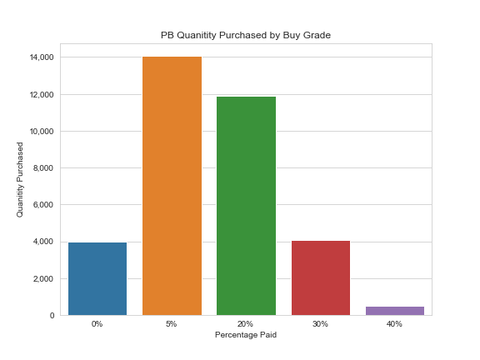

The main conclusion that can be made from this breakdown is that 5% and 20% offers make up the vast majority of paperback purchased. Offers of 40% are too infrequent to be consequential.

My next step was to perform the same analysis as the last step but looking at the total dollar amount of PB suggested offers.

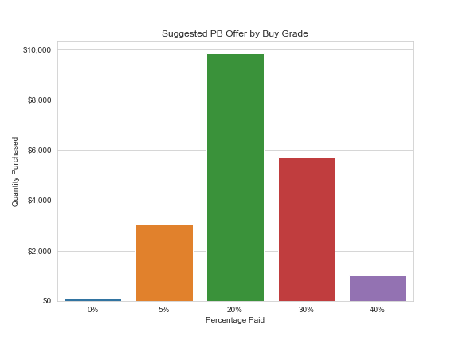

The data in this chart represents the actual suggested offers for PBs for all v1.r3 suggested offers. The average suggested offer per PB is $0.57 for 34,477 PBs resulting in a total cost of $19,723.84

It is clear from this breakdown that the majority of offer amounts suggested for PBs has been for C grade (20%) PBs., with a fairly large portion also composed of B grade (30%) offers. I hypothesized that adjusting the C grade percentage downwards would likely be the most effective way of normalizing PB costs to chain average.

Lastly, I adjusted percentages downwards until PB suggested offers were normalized to chain average. Adjusting only the C-grade offers downwards by 10% was insufficient. Suggested offers on PBs were only sufficiently normalized after offer percentages for grades A, B, and C were reduced by 10%

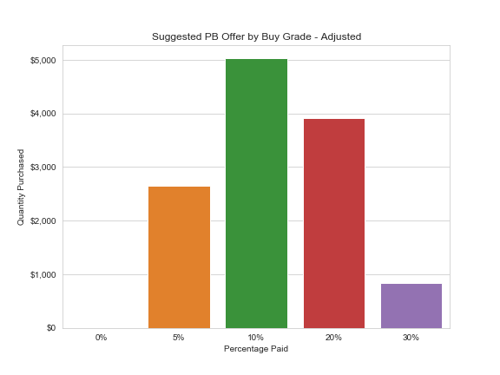

The data in this chart represents the adjusted suggested offers for PBs for all v1.r3 suggested offers.

Had we paid 10%, 20%, and 30% less for grade C, B, and A paperbacks instead of 20%, 30%, and 40% (respectively) the average suggested offer per PB would have been $0.36 for 34,457 PBs resulting in a total cost of $12,417.81 The chain average for PB offers during this time period was $0.34 per PB.

**Conclusion**

PB offers can be normalized to chain average by adjusting the percentage paid for A, B, and C grade PBs downwards by 10 % each, to 30%, 20%, and 10%, respectively.